1. Agenda:
   1. Through App, check if the duplicate msgs are handled without being reprocessed again.
2. 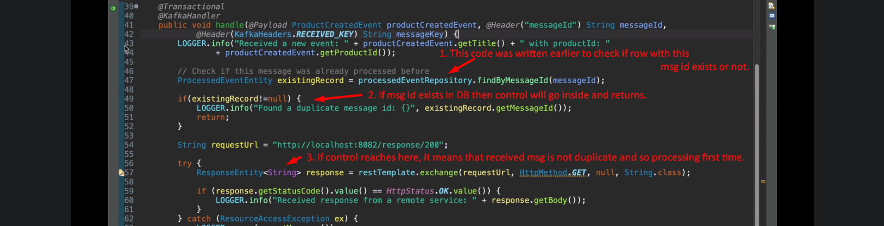
3. 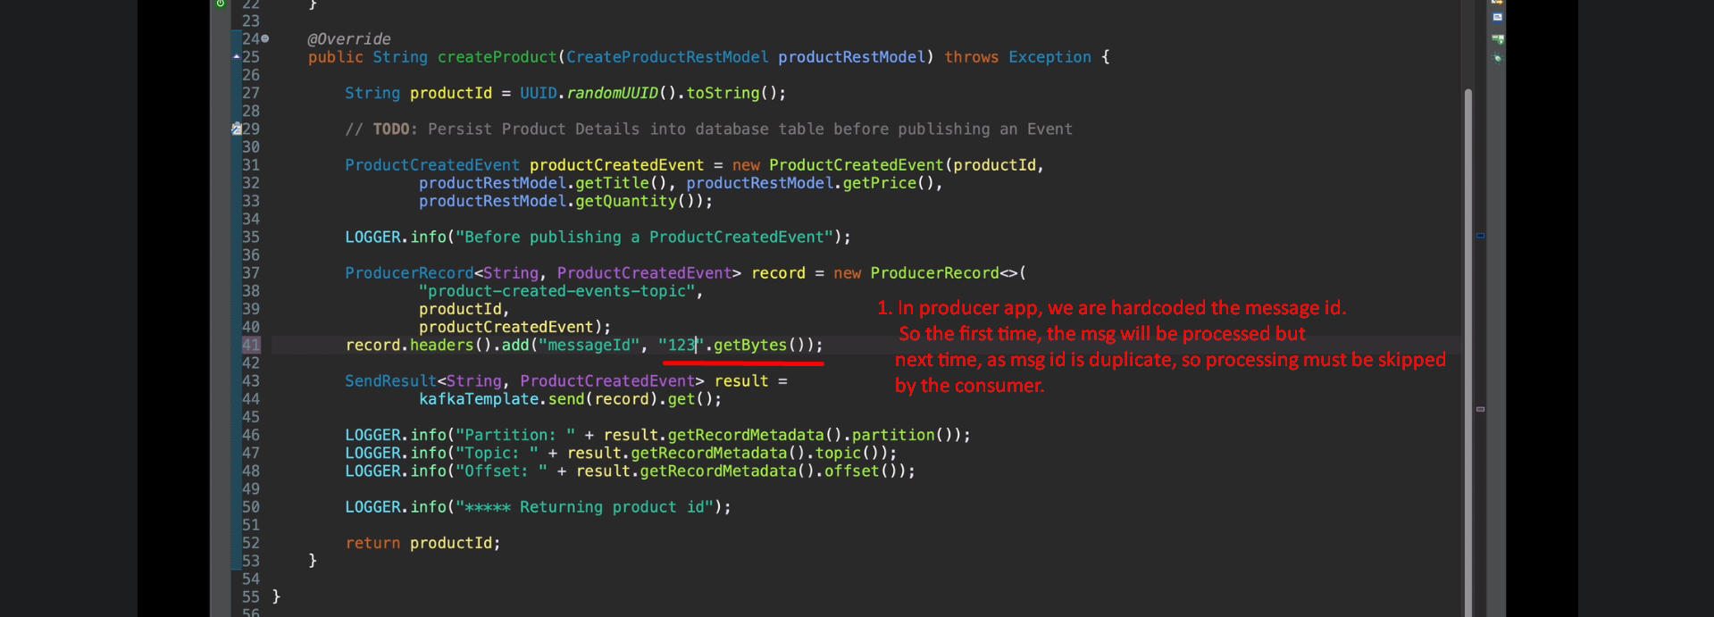
4. Let’s open H2 console.  
   
5. 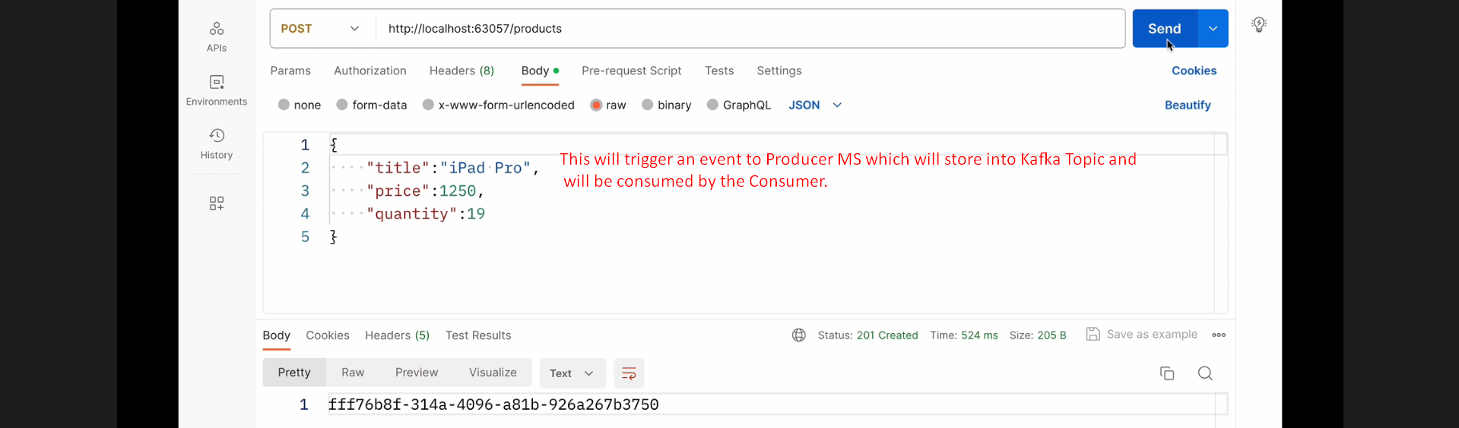
6. 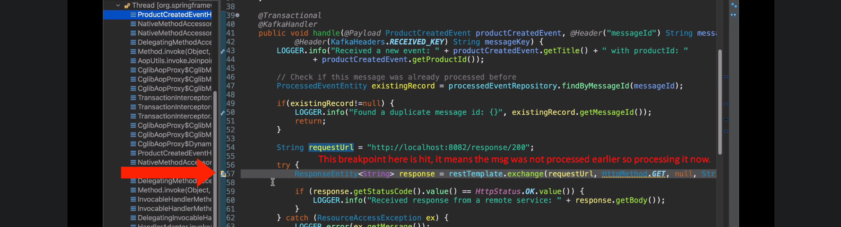
7. 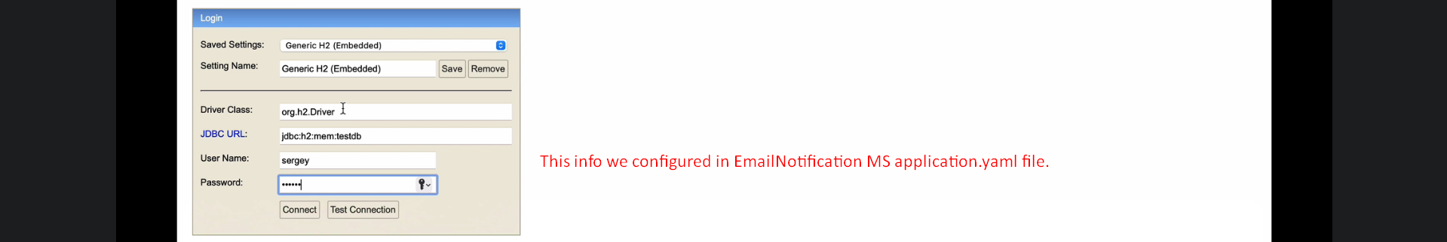
8. 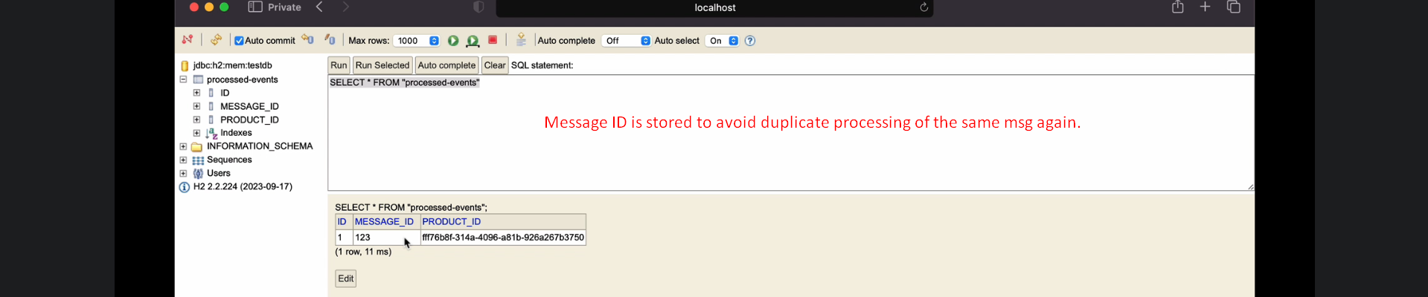
9. 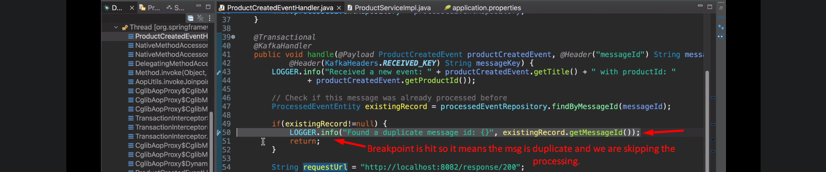
10. 